1. **DISCORDBOT_CREATE_GUILD_EMOJI**

2. **DISCORDBOT_GET_GUILD_EMOJI**

3. **DISCORDBOT_UPDATE_GUILD_EMOJI**

4. **DISCORDBOT_DELETE_GUILD_EMOJI**

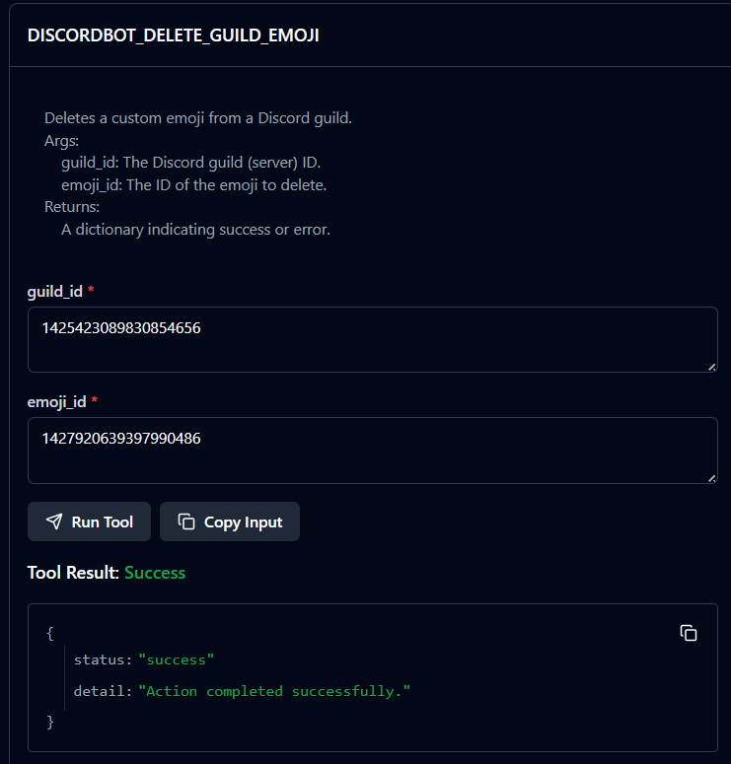

5. **DISCORDBOT_LIST_GUILD_EMOJIS**

6. **DISCORDBOT_CREATE_GUILD_STICKER**

7. **DISCORDBOT_GET_GUILD_STICKER**

8. **DISCORDBOT_UPDATE_GUILD_STICKER**

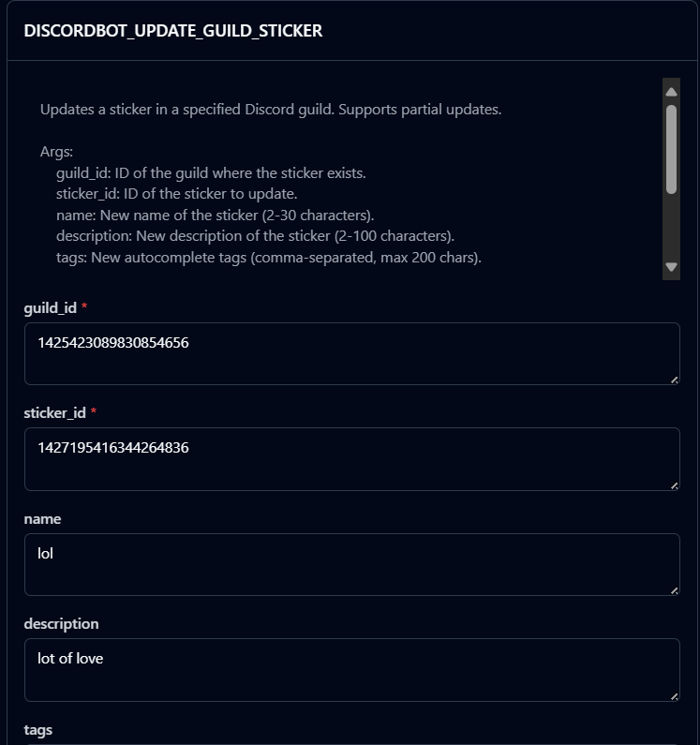

9. **DISCORDBOT_DELETE_GUILD_STICKER**

10. **DISCORDBOT_LIST_GUILD_STICKERS**

11. **DISCORDBOT_LIST_STICKER_PACKS**

12. **DISCORDBOT_GET_STICKER**

13. **DISCORDBOT_FOLLOW_CHANNEL**

14. **DISCORDBOT_TRIGGER_TYPING_INDICATOR**

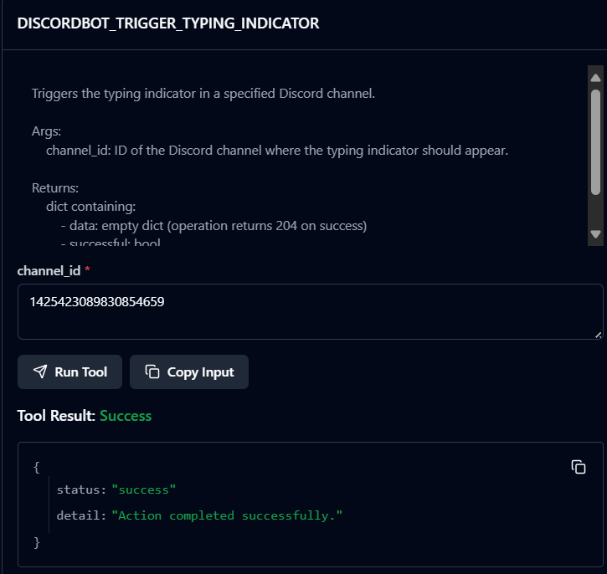

15. **DISCORDBOT_CROSSPOST_MESSAGE**

16. **DISCORDBOT_LIST_VOICE_REGIONS**

17. **DISCORDBOT_CREATE_DM**

18.DISCORDBOT_VIEW_DM_MEMBERS

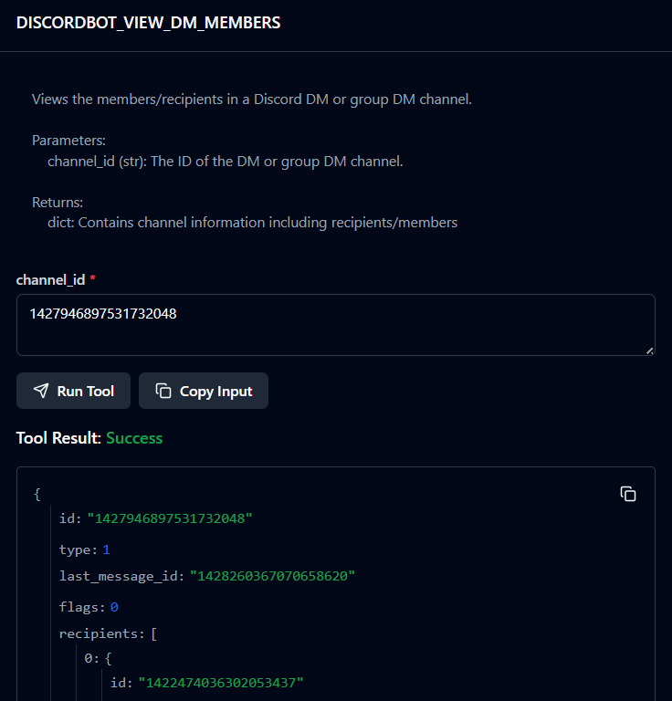

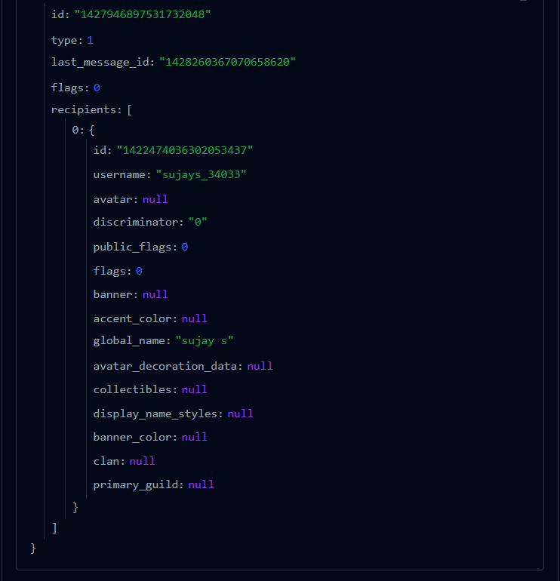

19. **DISCORDBOT_CREATE_GUILD**

Bots can’t create guild

20. **DISCORDBOT_DELETE_GUILD**

**Bot doesn’t own any guild to delete**

21. **DISCORDBOT_UPDATE_GUILD**

22. **DISCORDBOT_SEARCH_GUILD_MEMBERS**

23. **DISCORDBOT_GET_GUILD**

24. **DISCORDBOT_LIST_GUILD_CHANNELS**

25. **DISCORDBOT_LIST_GUILD_MEMBERS**

26. **DISCORDBOT_GET_GUILD_MEMBER**

27. **DISCORDBOT_UPDATE_GUILD_MEMBER**

28. **DISCORDBOT_DELETE_GUILD_MEMBER**

**29. DISCORDBOT_BAN_USER_FROM_GUILD**

**30. DISCORDBOT_UNBAN_USER_FROM_GUILD**

**31. DISCORDBOT_LIST_GUILD_BANS**

**32. DISCORDBOT_GET_GUILD_BAN**

**33. DISCORDBOT_PRUNE_GUILD**

**34. DISCORDBOT_PREVIEW_PRUNE_GUILD**

**35.** **DISCORDBOT_LIST_GUILD_ROLES**

**36. DISCORDBOT_CREATE_GUILD_ROLE**

**37. DISCORDBOT_UPDATE_GUILD_ROLE**

**38. DISCORDBOT_FORCE_REMOVE_BOT**

**39. DISCORDBOT_LIST_GUILD_INVITES**

**40. DISCORDBOT_CREATE_GUILD_FROM_TEMPLATE**

**Bot cannot create guild**

**41. DISCORDBOT_SYNC_GUILD_TEMPLATE**

**42. DISCORDBOT_GET_GUILD_TEMPLATE**

**43. DISCORDBOT_UPDATE_GUILD_TEMPLATE**

**44. DISCORDBOT_DELETE_GUILD_TEMPLATE**

**45. DISCORDBOT_CREATE_GUILD_TEMPLATE**

**46. DISCORDBOT_GET_GUILD_PREVIEW**

**47. DISCORDBOT_GET_GUILDS_ONBOARDING**

**48. DISCORDBOT_PUT_GUILDS_ONBOARDING**

**49. DISCORDBOT_GET_GUILD_WIDGET**

**50. DISCORDBOT_GET_GUILD_WIDGET_SETTINGS**

**51. DISCORDBOT_UPDATE_GUILD_WIDGET_SETTINGS**

**52. DISCORDBOT_GET_GUILD_WELCOME_SCREEN**

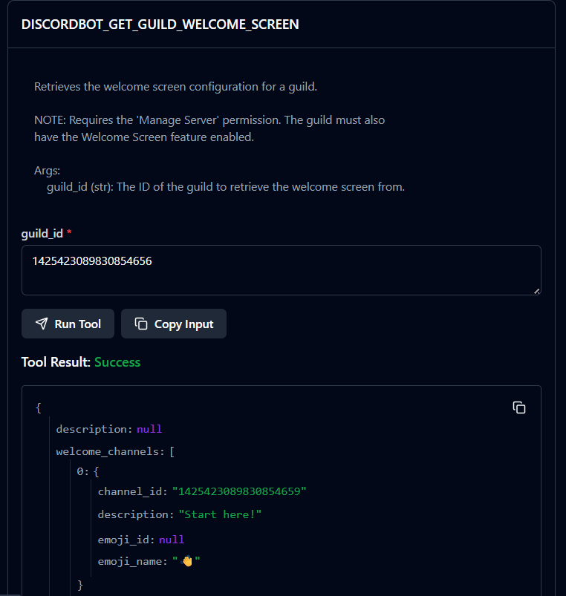

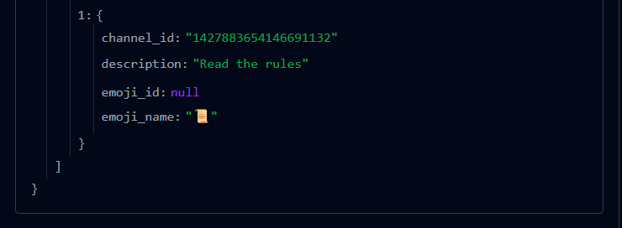

**53. DISCORDBOT_SETUP_GUILD_WELCOME_SCREEN**

**54. DISCORDBOT_GET_GUILD_WELCOME_SCREEN**

**55. DISCORDBOT_UPDATE_GUILD_WELCOME_SCREEN**

**56. DISCORDBOT_GET_GUILD_VANITY_URL**

**Requires server to be atleast level 2 or 3**

**57. DISCORDBOT_GET_GUILD_WEBHOOKS**

**58. DISCORDBOT_GET_GUILD_SCHEDULED_EVENT**

**59. DISCORDBOT_CREATE_GUILD_SCHEDULED_EVENT**

**60. DISCORDBOT_UPDATE_GUILD_SCHEDULED_EVENT**

**61. DISCORDBOT_DELETE_GUILD_SCHEDULED_EVENT**

**62. DISCORDBOT_LIST_GUILD_SCHEDULED_EVENTS**

**63. DISCORDBOT_LIST_GUILD_VOICE_REGIONS**

**64. DISCORDBOT_LIST_GUILD_INTEGRATIONS**

**65. DISCORDBOT_CREATE_WEBHOOK**

**66. DISCORDBOT_GET_WEBHOOK**

**67. DISCORDBOT_UPDATE_WEBHOOK**

**68. DISCORDBOT_DELETE_WEBHOOK**

**69. DISCORDBOT_GET_WEBHOOK_BY_TOKEN**

**70. DISCORDBOT_UPDATE_WEBHOOK_BY_TOKEN**

**71. DISCORDBOT_DELETE_WEBHOOK_BY_TOKEN**

**72. DISCORDBOT_EXECUTE_WEBHOOK**

**73. DISCORDBOT_EXECUTE_SLACK_COMPATIBLE_WEBHOOK**

**74. DISCORDBOT_EXECUTE_GITHUB_COMPATIBLE_WEBHOOK**

**75. DISCORDBOT_GET_WEBHOOK_MESSAGE**

**76. DISCORDBOT_UPDATE_WEBHOOK_MESSAGE**

**77. DISCORDBOT_DELETE_WEBHOOK_MESSAGE**

**78. DISCORDBOT_GET_ORIGINAL_WEBHOOK_MESSAGE**

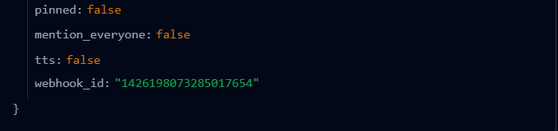

**79. DISCORDBOT_UPDATE_ORIGINAL_WEBHOOK_MESSAGE**

**80. DISCORDBOT_DELETE_ORIGINAL_WEBHOOK_MESSAGE**

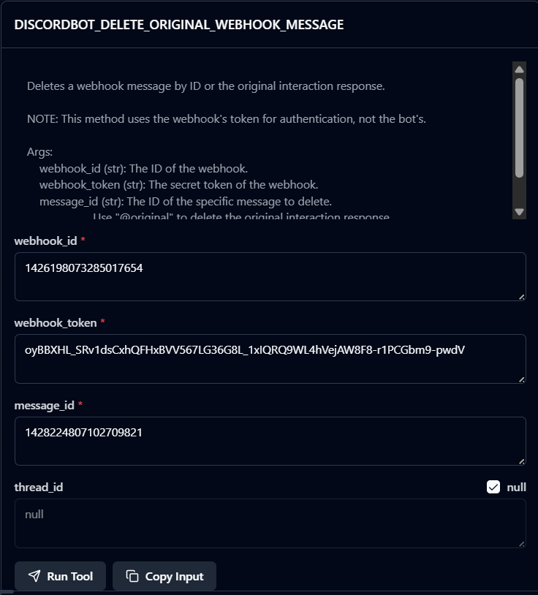

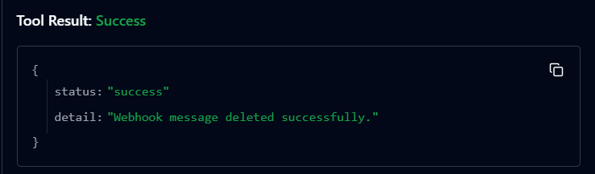

**81. DISCORDBOT_LIST_CHANNEL_WEBHOOKS**

**82. DISCORDBOT_INVITE_RESOLVE**

**83. DISCORDBOT_INVITE_REVOKE**

**84. DISCORDBOT_CREATE_CHANNEL_INVITE**

**85. DISCORDBOT_LIST_CHANNEL_INVITES**

